Inflectra Single Dose Vial CONSUMER-LEVEL RECALL - CUSTOMER CARE TALK TRACK

Background Information: On January 17, 2025, McKesson Pharma issued a consumer-level recall of Inflectra® Single Dose Vial NDC # 00069-0809-01, manufactured by Pfizer. This recall was issued because the product experienced a temperature excursion. This recall is being undertaken voluntarily to ensure the highest standards of safety and quality. This recall is to the consumer-level.

This recall affects lot number 04647349. Product shipped from McKesson Pharma Distribution Center in Jeffersonville, OH between Jan 2-8, 2025.

This recall action is being made with the knowledge of the U.S. Food and Drug Administration. To date, McKesson Pharma has not received any reports of adverse events or injuries related to this recall.

McKesson Pharma Customer Instructions:
- Immediately examine your inventory and quarantine all product subject to this urgent product recall. The recall is limited to your specific order and items detailed in the table above.
- Please complete and return the enclosed response form (Attachment #1) as soon as possible, even if you do not have any product on hand or have already returned the product. Return the completed form to ProductRecall@McKesson.com. Note: McKesson will not issue a return kit; please follow the normal process of creating a Received Defective Return Authorization through McKesson Connect. Credits or replacements will be processed by McKesson for full quantities of all the verified orders that are within the scope of this urgent product recall.
- NOTE: Replacement product may have the same lot number(s) as the recalled items. Those replacement items are not affected by the recall and are acceptable for use.
- If you have further distributed this product to end users or patients, please notify them immediately of this urgent product recall and ask them to segregate and quarantine this product immediately. You are encouraged to include a copy of this notification letter in your communication with any of these end users. Patients should return affected product to their dispenser.

Please note: This product is not carried by the CVS Caremark Mail Service Pharmacies.

Customer Care Talk Track:

** Please ensure to disposition all recall calls to code “1116” **

Q# | Question | Action | Answer
1 | I heard that there is an issue with my medicine, Inflectra® Single Dose Vials. Can you give me more information? | Note: Check PeopleSafe to determine if the medication is from Mail or Specialty Pharmacy | If the medication was dispensed from… | Then say…
1 |  |  | Mail Order | - Yes, I can.  - Proceed to Q2
1 |  |  | Specialty | While in PeopleSafe, determine the phone number of the dispensing Specialty pharmacy and transfer the call.  A: Yes, I can. Please hold while I transfer you to your Specialty Pharmacy.

Customer Care/Specialty Talk Track Clinical Care Service/Specialty Pharmacy Talk Track
2 | Why is there a recall? What is wrong with the product? |  | On January 17, 2025, McKesson Pharma issued a consumer-level recall of Inflectra® Single Dose Vials, manufactured by Pfizer. This recall was issued because the product experienced a temperature excursion.  For more information, call McKesson toll-free at 1-855-625-6285. You may also call the United States Food and Drug Administration (FDA) toll-free at 1-888-INFO-FDA (1-888-463-6332) or visit www.fda.gov.
3 | May I return the rest of the Inflectra® Single Dose Vials that I have? | Determine if the patient is affected by this recall | First, let’s determine if you are affected by this recall:
3 |  | Determine if the patient is affected by this recall | If the product was dispensed in… |  | Then say...
3 |  | Determine if the patient is affected by this recall | Manufacturer’s Package |  | - Check the lot number. The lot number is on the manufacturer’s label on the vial.  - If your drug is not from this affected lot number, it is not affected by this recall.  Please note: This product is not carried by the CVS Caremark Mail Service Pharmacies. If your drug is from this affected lot number, CVS Caremark® Specialty Pharmacy will send you replacement product and a postage-paid envelope to return the affected product. If you received any recalled product from your retail pharmacy, please contact the pharmacy that filled your prescription for more information including return instructions.  Please note: If the member received recalled product, please submit a damaged bottle reship order and indicate the amount of replacement product to be sent. Please make sure to request call tag.
4 | Should I stop using my Inflectra® Single Dose Vials? |  | If the medication was dispensed from… |  | Then say…
4 | Should I stop using my Inflectra® Single Dose Vials? |  | Mail Order |  | Customer Care:  Please hold while I transfer you to one of our Clinical Counseling Clinicians.  Clinical Care Service:  McKesson recommends that consumers should segregate and quarantine this product immediately. Consumers should return affected product to their dispenser. Please call your health care professional right away for advice if you may be using affected product or if you do not know if you used affected drug. Your doctor is familiar with your medical history and can suggest the best treatment option for you.
4 | Should I stop using my Inflectra® Single Dose Vials? |  | Specialty |  | Customer Care:  Please hold while I transfer you to your Specialty Pharmacy.  Clinical Care Service:  McKesson recommends that consumers should segregate and quarantine this product immediately. Consumers should return affected product to their dispenser. Please call your health care professional right away for advice if you may be using affected product or if you do not know if you used affected drug. Your doctor is familiar with your medical history and can suggest the best treatment option for you.
5 | Will I receive credit for the product I return? |  | Your insurance will be credited for any affected product returned to us. We will replace the affected product with unaffected product. You will not be charged any additional copayments.

Additional Information:

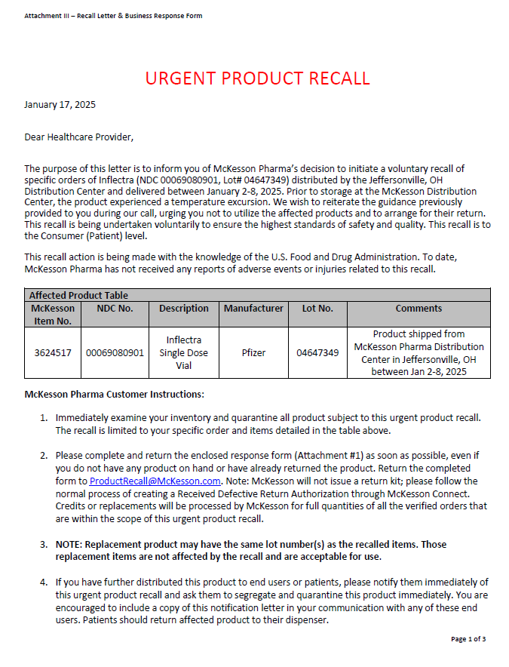

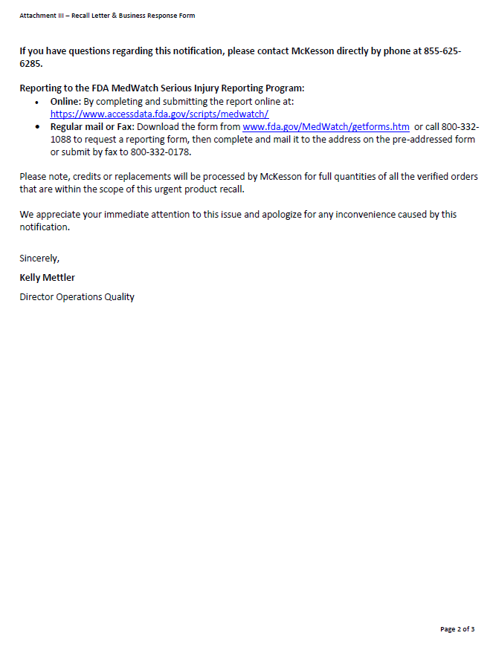

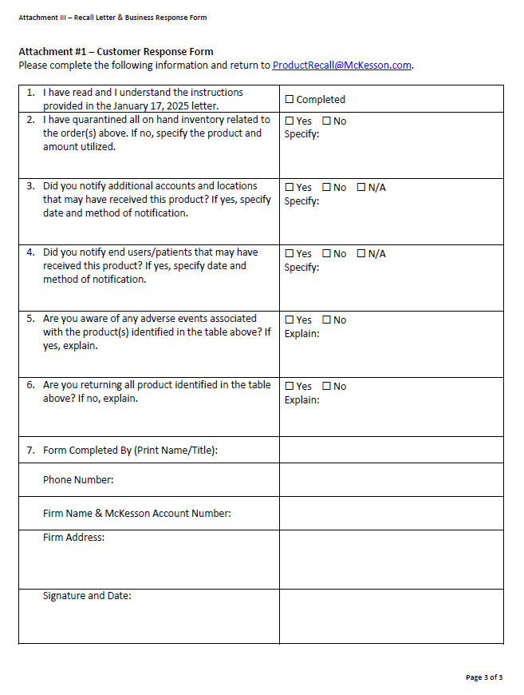
Top of the Document

Not to Be Reproduced or Disclosed to Others without Prior Written Approval
ELECTRONIC DATA = OFFICIAL VERSION / PAPER COPY = INFORMATIONAL ONLY

